Date: _____________

____________________________________

____________________________________

____________________________________

Re: ___________________________ (child name) DOB: _________________ 3rd Birthday: __________

Entry to AEIS (initial IFSP date): ___________

Parent: _____________________________ Address: ______________________________________

Phone: __________________________ ______________________________________

County: ______________________________________

Dear_________________________,

_____ *I am notifying your LEA that the above mentioned child was ELIGIBLE (eligibility date :________) for EI less than 90 days prior to his/her third birthday. No transition meeting will be scheduled.*

_____ I am extending an invitation to you or a designated LEA representative to attend a Transition Planning Meeting.

Based on the family’s current residency and their understanding of the school districts for their neighborhood, they have asked me to notify you of their child’s impending third birthday and their wish to have an evaluation to determine eligibility for services under Part B. While assisting this family in developing a Transition Plan, I have provided information about the transition process and community placement options available to the child at age three, including information about your Local Education Agency (LEA) as an important option.

The purpose of the Transition Planning Meeting is to introduce you to the parents, provide them an opportunity to ask questions about the LEA and discuss the referral process and eligibility guidelines.

Based on federal requirements, we should agree to convene a Transition Planning Meeting prior to the child turning 33 months or as soon as possible based on the IFSP date. For purposes of the Transition Planning Meeting it is necessary that only one LEA representative be present. Of course, if it is convenient for your IEP Team to combine this meeting with the LEA Referral Meeting, we will be happy to accommodate based on the convenience for the family, but please allow additional time. Convenient times for this family to meet are: _________________________________________________________________________________.

Please acknowledge receipt of this notification by e-mail.

Service Coordinator: Phone: ________________ E-mail: ________________

Sincerely,

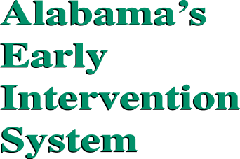 Service Coordinator

EI Program

Address